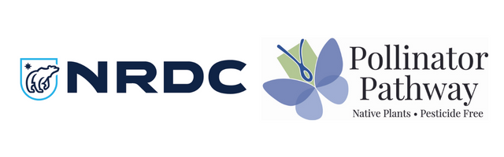
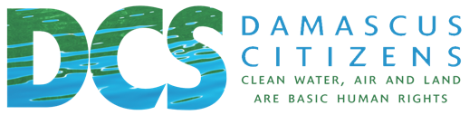

FIND YOUR REPRESENTATIVES HERE

SAMPLE EMAILS TO REPRESENTATIVES

Dear [REPRESENTATIVE’S NAME],
My name is [YOUR NAME] and I am a constituent from [TOWN/CITY] and a member of [GARDENCLUB/POLLINATOR PATHWAY/OTHER ORGANIZATION]. I’m writing today to urge you to support the Birds and the Bees Protection Act (A7429A-Englebright/S699D-Hoylman in the 2021-2022 session), which would protect our state against the harmful and unnecessary uses of toxic neonicotinoid pesticides or “neonics.”
Widespread and wasteful neonic use is a lead cause of dramatic declines in bees and other pollinators, which is already harming production of top state crops like apples and New York’s ecosystems at large. But the threats neonics pose are much bigger than bees. These pesticides extensively contaminate New York water, often at levels linked to mass losses of birds, the collapse of fisheries, and birth defects in white-tailed deer. A growing chorus of health experts are also raising alarms about neonics’ threats to New Yorker’s health, likening the pesticides to other neurotoxins like lead and mercury, for which there is no safe level. Evidence suggests that widespread neonic pollution is increasing, with a recent study not only finding neonics in 96% of 171 pregnant women tested from New York and several other states, but also showing that those neonic levels have been steadily increasing over the past several years.
The Birds and Bees Protection Act would eliminate 80-90% of these dangerous chemicals from entering New York’s environment every year by prohibiting only those neonic uses that extensive Cornell University research found either provide no benefit to users or are easily replaced with safer alternatives. While the bill passed in the Senate and Assembly in separate years, it has yet to pass both houses in the same year.
Every year New York fails to act to rein in neonic pollution, more bees and birds die, more of our water is contaminated, and more New Yorkers are harmed. With the problem only getting worse, I ask you to support a renewed Birds and Bees Protection Act in the 2023 session, and do all that you can to ensure that it passes the full legislature as soon as possible.
Thank you for your time and service,
NAME

SAMPLE SCRIPT FOR REPRESENTATIVE CALLS

Hello
My name is [YOUR NAME] and I’m a constituent of [REPRESENTATIVE] from [TOWN/CITY] and a member of [GARDENCLUB/POLLINATOR PATHWAY/OTHER ORGANIZATION]. I’m calling today to urge [REPRESENTATIVE] to support the Birds and the Bees Protection Act (A7429A-Englebright/S699D-Hoylman in the 2021-2022 session).
What would this act do?
- Protect our state against toxic neonic pesticide contamination
- An overwhelming body of scientific evidence identifies neonics as a lead driver of mass losses of bees and other pollinators. That’s bad news for New York’s ecosystems and New York farmers that rely on pollination provided by bees. Already, top crops like apples, blueberries, and cherries are affected, with recent research showing that farmers are growing fewer of these crops because of a lack of bees and other pollinators.
- Neonic pesticides extensively contaminate New York water supplies, and because most conventional drinking water treatment fails to remove neonics, New Yorkers are at considerable risk of seeing these neurotoxic pesticides in their tap water. This is
- A growing body of evidence also links the neonic water contamination we see in New York to a broad range of environmental harms, including mass losses of birds, the collapse of fisheries, and birth defects in white-tailed deer.
- New York health experts are also raising alarms about neonics’ threats to New Yorker’s health, likening the pesticides to other neurotoxins like lead and mercury, for which there is no safe level, especially for children and pregnant women.
- Worryingly, evidence shows that New Yorkers are extensively exposed to neonic pollution and the problem is only getting worse. A recent study found neonics in 96% of 171 pregnant women tested from New York and several other states, and also that those neonic levels have been steadily increasing over the past several years.
- Every year New York fails to act, more bees and birds die, more of our water is contaminated, and more New Yorkers are harmed.
- The Birds and Bees Protection Act is a commonsense measure to curb dangerous neonic pollution in New York. It would eliminate 80-90% of the neonics entering the state’s environment every year by prohibiting only those uses that are unnecessary or easily replaced with safer alternatives.
- With the problem only getting worse, I ask you to support a renewed Birds and Bees Protection Act in the 2023 session, and do all that you can to ensure that it passes the full legislature as soon as possible. Thank you for your time and concern.
[If you get into specifics] Specifically, the bill prohibits neonic-treatments on corn, soybean and wheat seeds, which is the single largest and most widespread use of neonics in New York, but one that extensive Cornell University research has found provides no overall economic benefits to farmers. It also prohibits lawn and garden neonic uses that Cornell research similarly finds are needless or replaceable with effective alternatives, while preserving the ability to use neonics, where necessary, to combat invasive species and other harmful pests.

